b
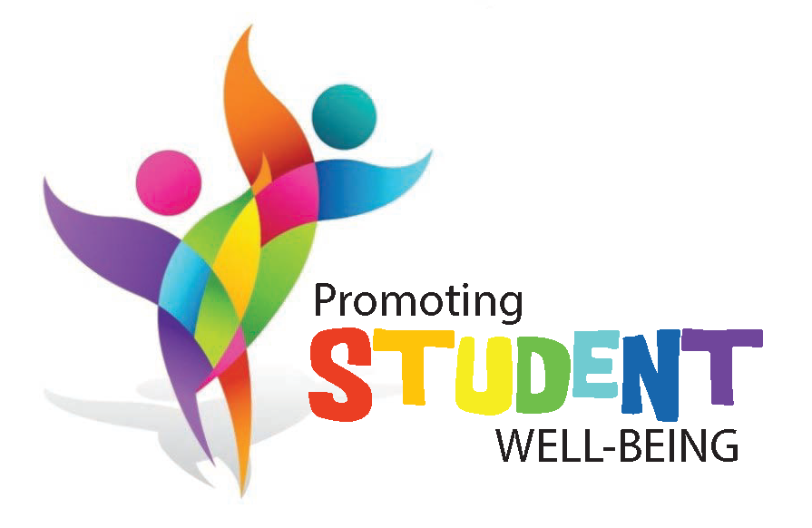

Dear Parent/Caregiver,

Did you know that October is Child Abuse Prevention Month?

The Children’s Aid Society of Haldimand and Norfolk, and Brant Family and Children’s Services are working together with schools, health care providers, police, and the community to keep children safe. Child abuse is not an easy topic to talk about, but it is important to include parents, caregivers, and families in raising awareness around a serious issue that exists in our community. Vulnerable children and youth depend on an aware and active community to get the help that they need.

This year October 19, 2016 is GO PURPLE DAY. Children’s Aid Societies will be working with schools and other organizations across the province to GO PURPLE and break the silence that surrounds child abuse.

Our Catholic Elementary Schools play an important role in keeping children safe and helping them grow, and are excited to participate in GO Purple Day on Wednesday, October 19, 2016. All elementary students and staff across the board are invited to participate by wearing purple on Wednesday October 19. You and your family can wear purple too! Additionally, as we strive to communicate a knowledge that is filled with the Gospel, we will be emphasizing in the classroom the strong connection between our Board theme of “Love Tenderly” and the importance of child protection.

We would like to thank you in advance for your participation in our GO PURPLE DAY on October 19, 2016. Together we can break the silence and keep children safe in our community. More information on Child Abuse Prevention Month, is available at www.cashn.on.ca or www.oacas.org.

Respectfully,

Dianne Wdowczyk-Meade
Mental Health Lead
Brant Haldimand Norfolk Catholic District School Board

